Instructions for assembly:
- Remove the ceiling tile from ceiling to prepare for bracket installation.
- Sketch the profile onto the tile or create a template using the measurements shown below. For Cisco 3800/4800/9115/9117/9120 or Aruba AP-515, refer to Figure 1A. If using an Aruba AP-535/AP-555 or Cisco 9130, see Figure 1B.
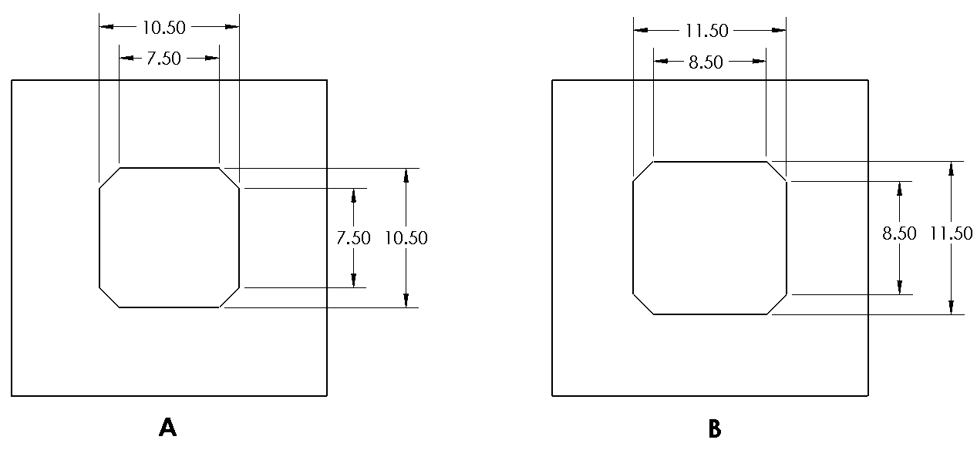
Figure 1.
- Using a sharp bladed tool, such as a utility knife, score the profile into the tile. Continue to score the outline deeper until the cut is complete. Remove the waste piece and dispose.
- If using a Cisco AP attach the AP to the access point bracket by sliding its feet into the keyhole pattern, as seen in Figure 2. If using an Aruba AP, remove the standard Aruba mounting bracket from the AP and attach to the tile AP bracket reusing the QTY (2) screws that came with the Aruba AP. The remaining steps are the same for any access point.
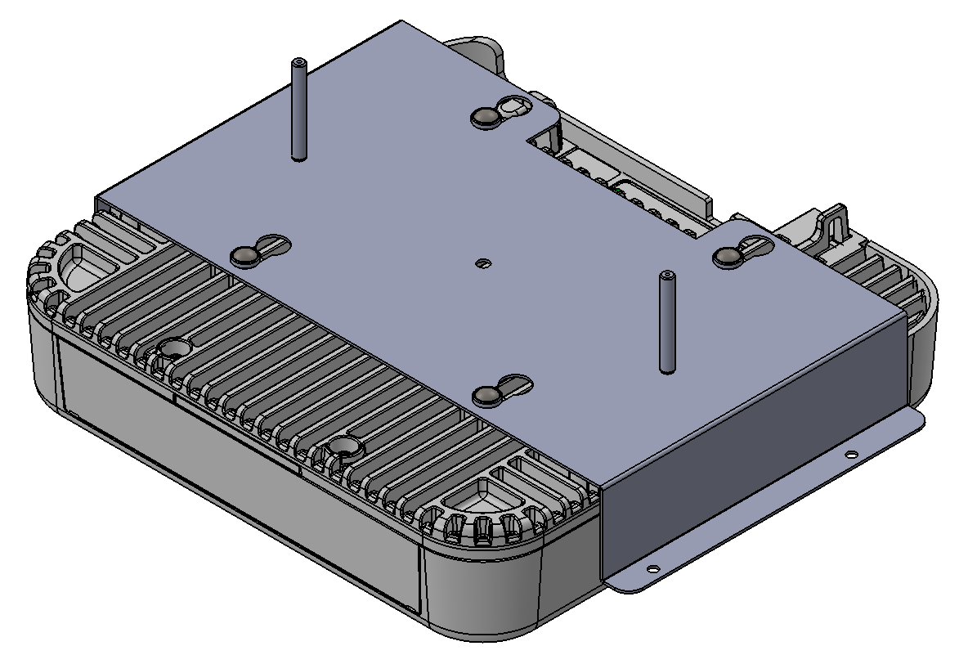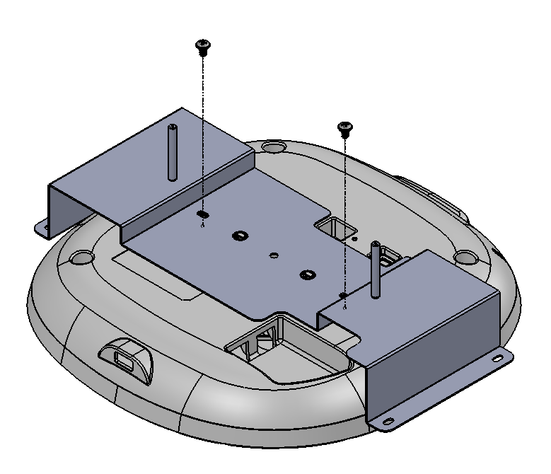
Figure 2.

- Next, place the bracket with the attached access point onto the face plate, aligning the holes and the threaded studs. Fasten with hex nuts. See Figure 3.
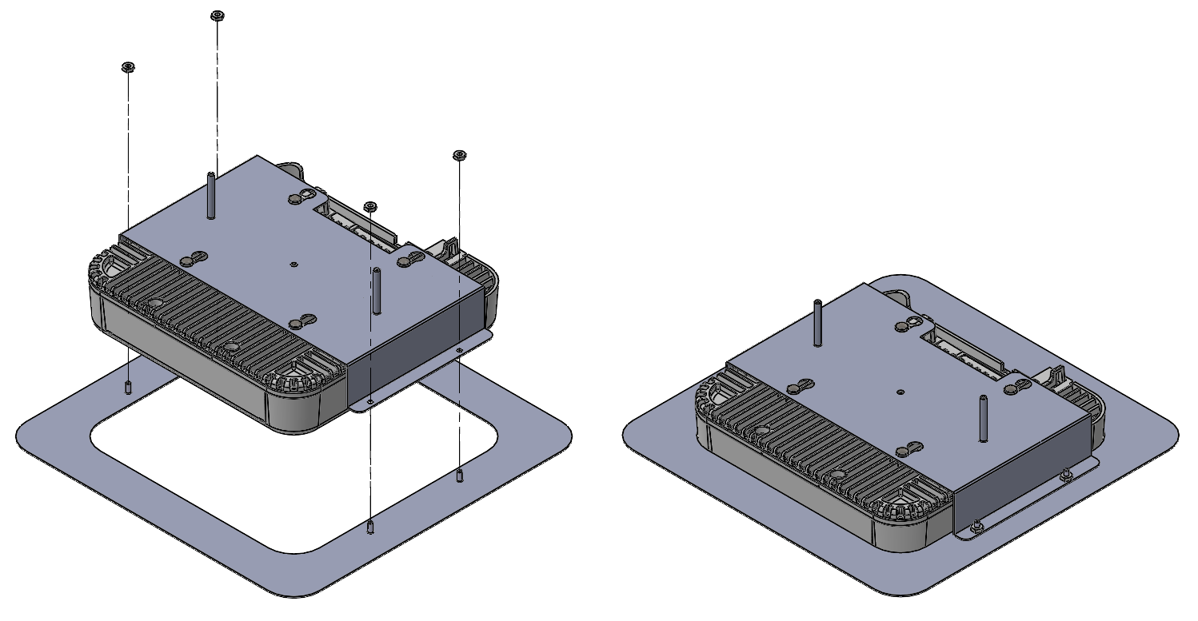
Figure 3.
- Place the tile onto the bracket with the attached face plate and access point, as shown in Figure 4.
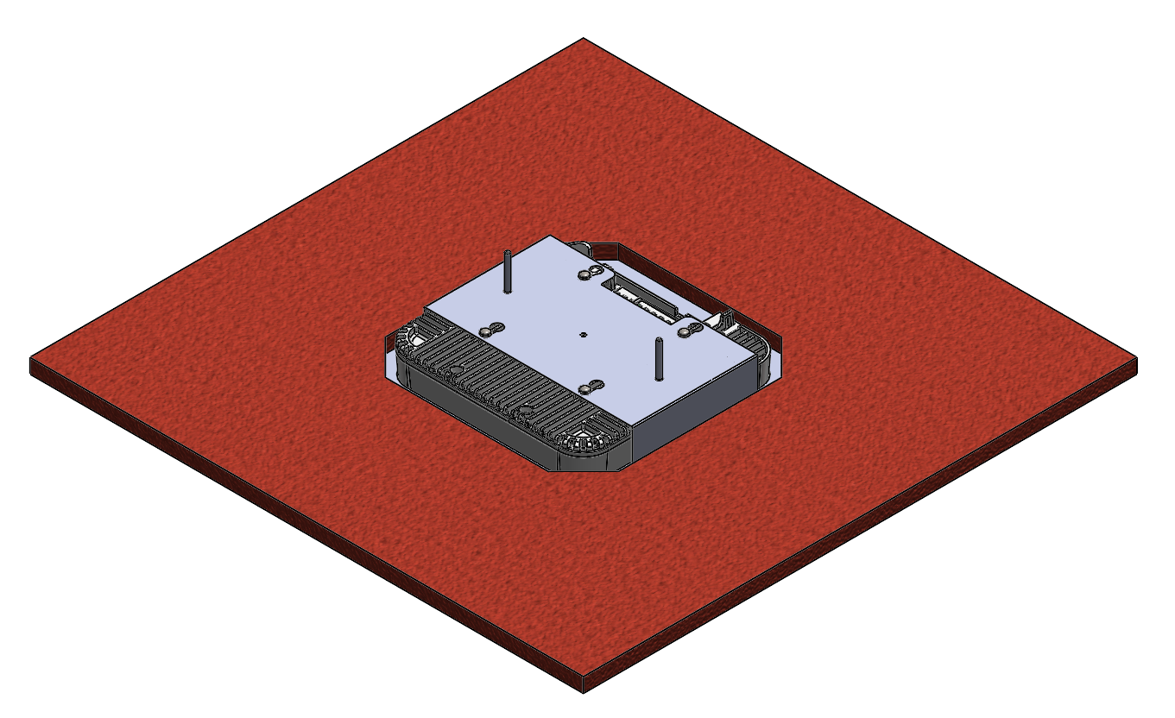
Figure 4.

- Place the strut over the bracket, aligning the holes onto the threaded studs of the bracket. Begin threading the wing nuts onto the threaded studs. Take care as to not overtighten, as the face plate could bend. See Figure 5. Check the front of the tile to assess the centering of the assembly and adjust as necessary.

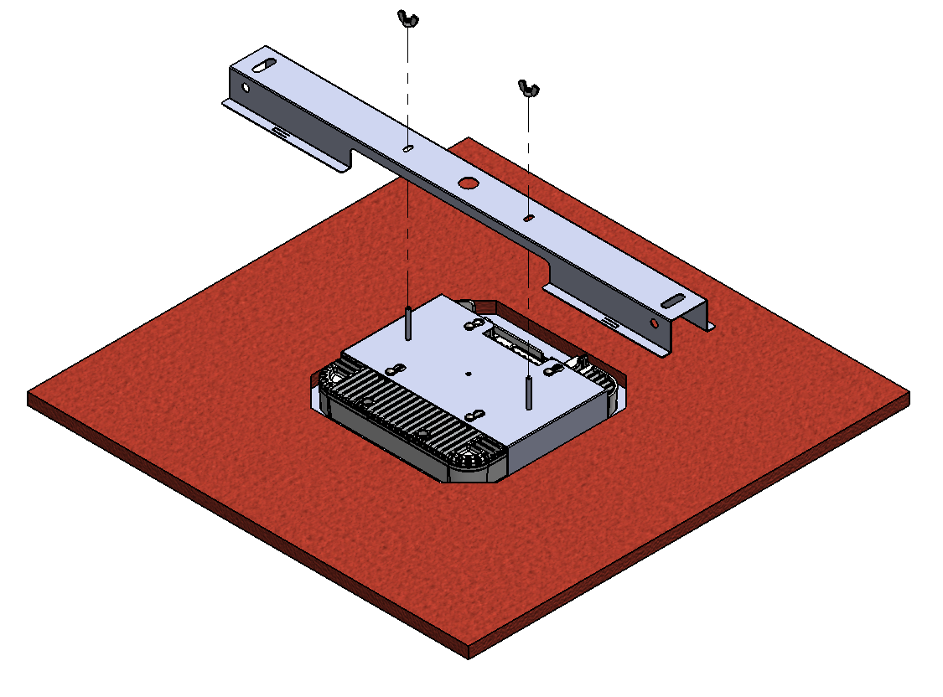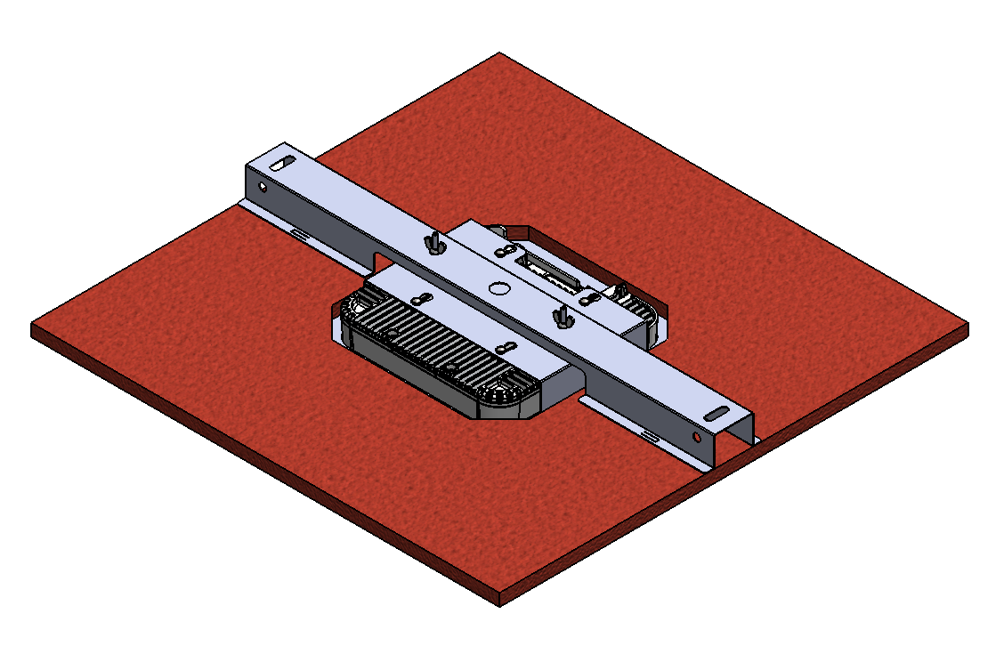
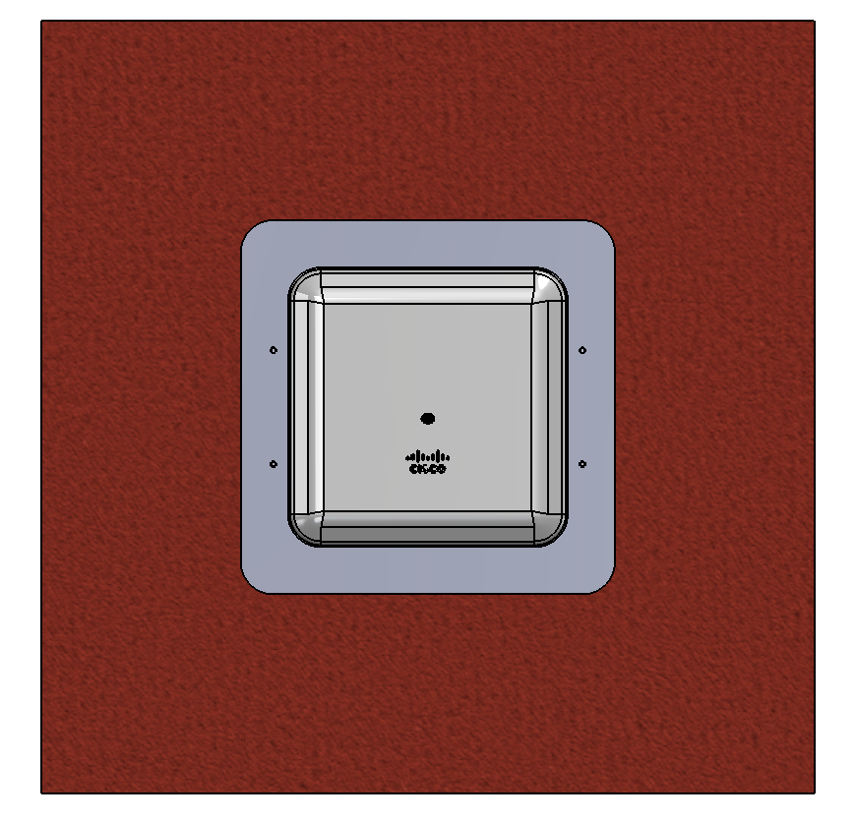
Figure 5.

- Optionally, to prevent the assembly from rotating, tabs in the strut can be bent down into the tile to bite into the surface. The tab locations are shown in Figure 6. With the AP assembly located in its desired position, simply bend the tabs down with a screwdriver.
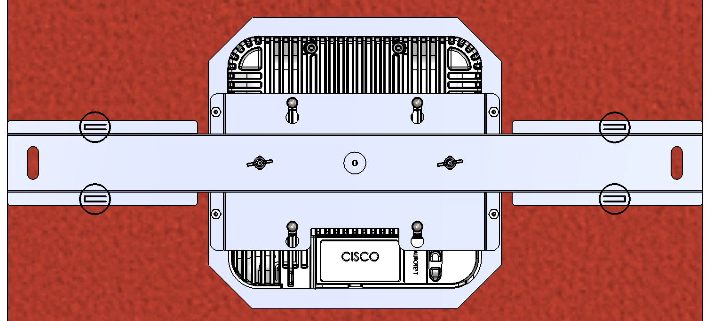
Figure 6.

- The tile is now ready to be installed into the ceiling, according to your local building code. In some locations, wiring the tile to the building structure might be required. There are holes cut into the strut for tying wires, as shown in Figure 7. To facilitate installing the tile and/or wiring your access point, you may remove the adjacent tile.

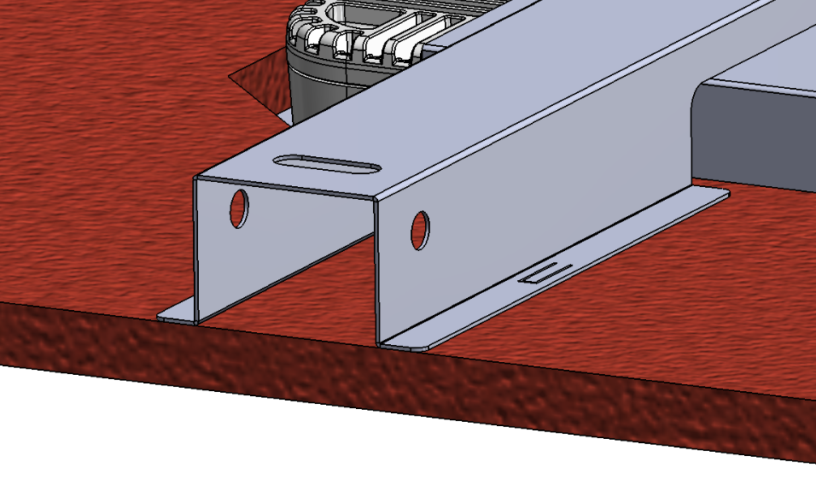
Figure 7.

