- Install the included cable gland on the box and run ethernet cable in.
- This enclosure accommodates the Cisco 3800E (hole pattern A), 9120E (hole pattern B), and the 9130E (hole pattern C) access points. Because of the unique mounting feet locations on the access points, 3 different hole patterns are provided on the mounting plate. Attach the Cisco low profile mounting bracket to the back plate using QTY (4) #8 screws as shown in Figure 1.
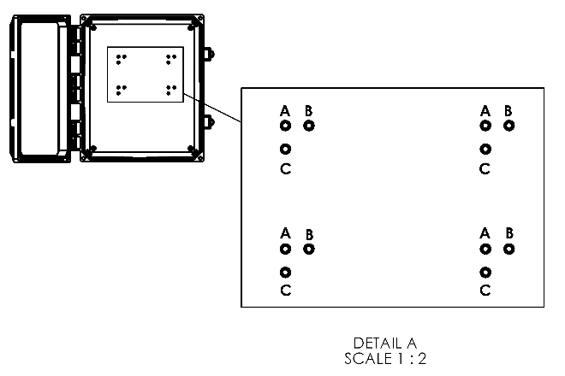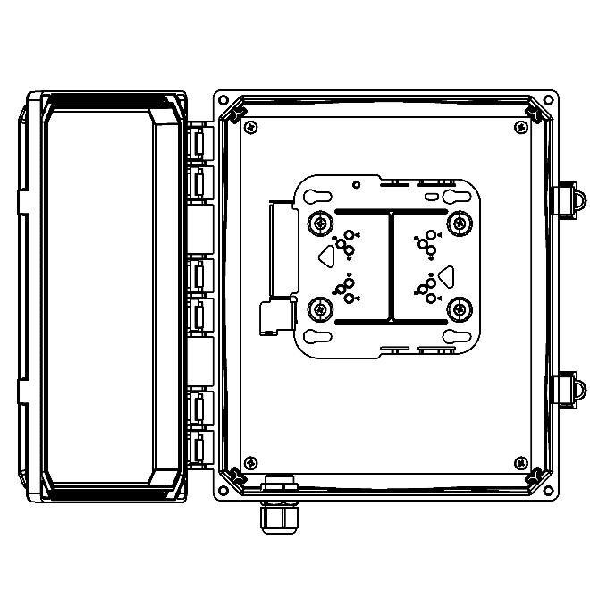
Figure 1.
- Plug in the ethernet cable and the DART cable and then slide the access point into the mounting bracket. Note: 9130E must be used with a right-angle DART cable in the 12x10x6 enclosure.
- Install bulkhead jumpers (not included) to the bottom of the enclosure coming from DART and external antenna ports of AP.

