- Install the included cable gland on the box and run ethernet cable in.
- This enclosure accommodates the Cisco 3800E, 9120E, and the 9130E access points using both straight and right angle DART connectors. For straight DART connectors, orient the Cisco low profile bracket in orientation A. For right angle DART connectors, orient the Cisco low profile bracket in orientation B. Attach mounting bracket to the back plate using QTY (4) #8 screws. See Figure 1.
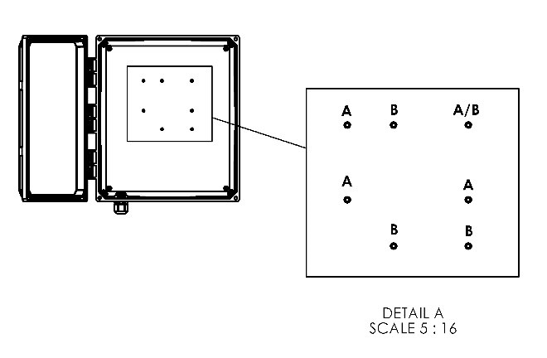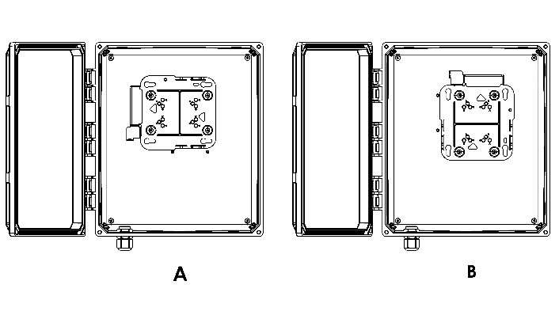
Figure 1.
- Plug in the ethernet cable and the DART cable and then slide the access point into the mounting bracket.
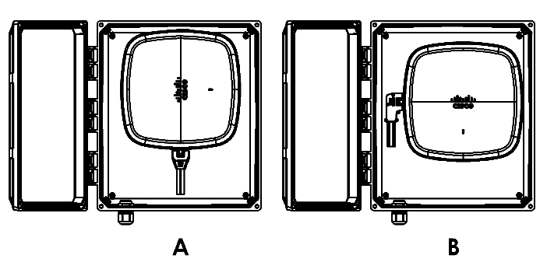
Figure 2.
- Install bulkhead jumpers (not included) to the bottom of the enclosure coming from DART and external antenna ports of AP.

