- Install the included cable gland on the box and run ethernet cable in.
- This enclosure accommodates the Cisco 9130AXE access point using both straight and right angle DART connectors. For straight DART connectors, orient the Cisco low profile bracket in orientation A. For right angle DART connectors, orient the Cisco low profile bracket in orientation B. Attach mounting bracket to the back plate using QTY (4) #8 screws. See Figure 1.
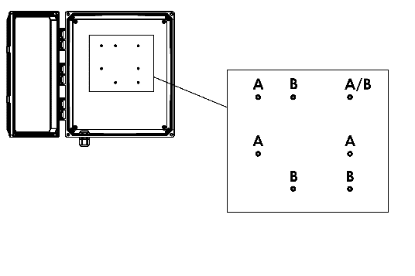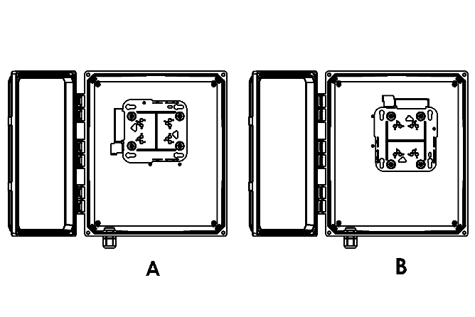
Figure 1.
- Install the cable gland as shown in Figure 2. Tighten cable gland screws to 2 Nm (1.48 lbf⋅ft).
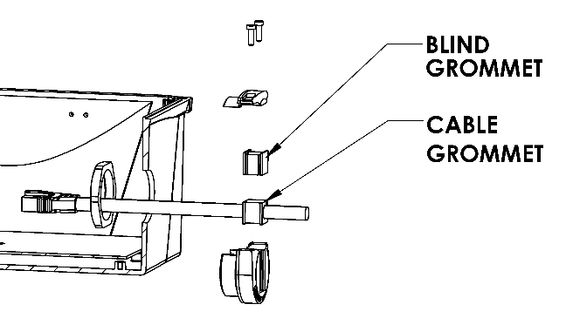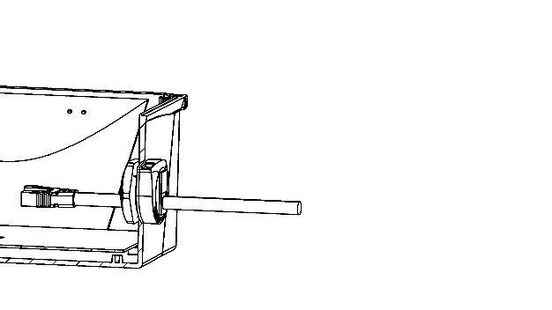
Figure 2.
- Plug in the ethernet cable and the DART cable and then slide the access point into the mounting bracket.
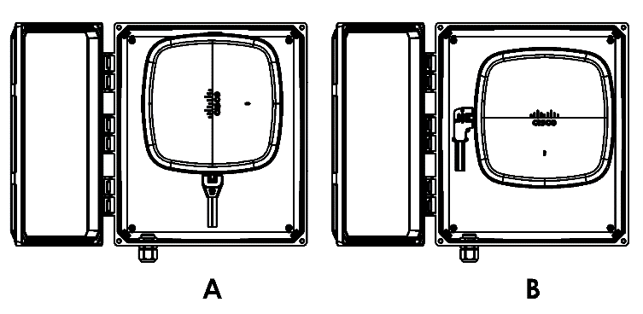
Figure 3.

